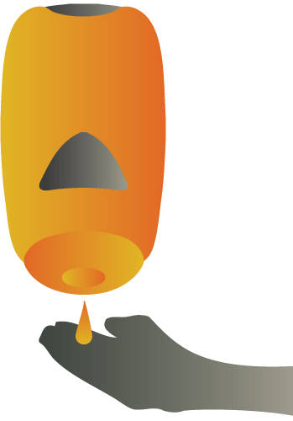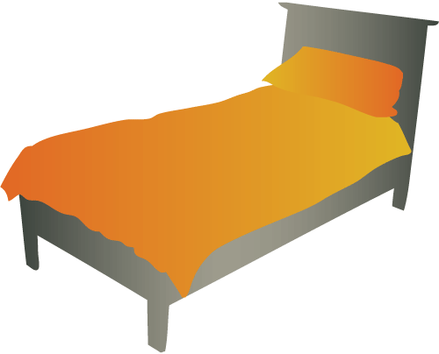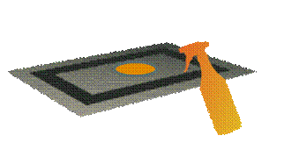**AST-CanTrashSm.gif**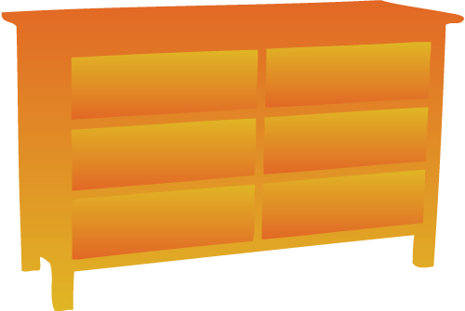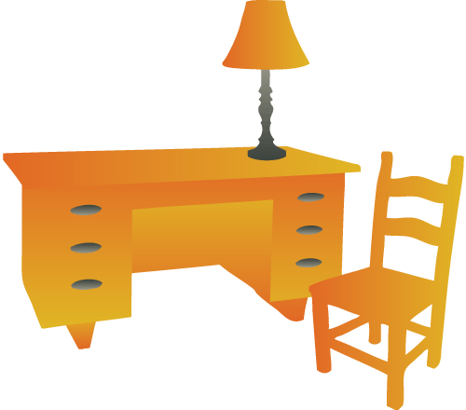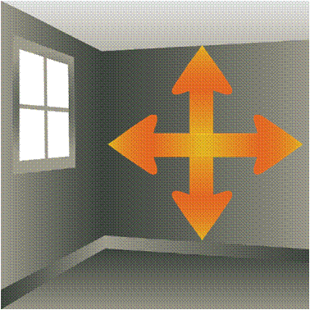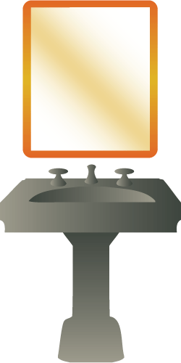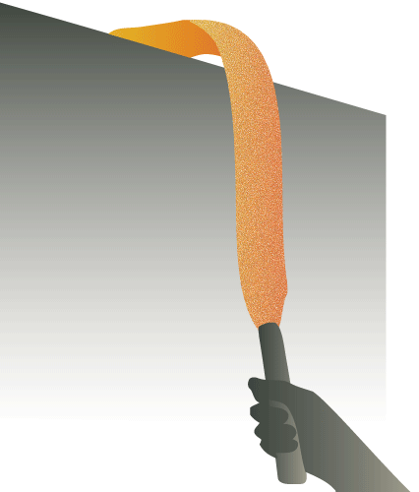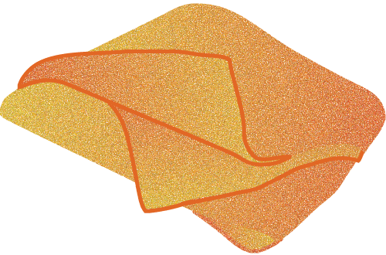 **Resident Room Cleaning – LTC Memory Care**

**Spot clean glass**

**Spot clean chairs / tables / vertical and horizontal surfaces**

**Empty trash containers / spray interior / spot clean exterior / reline**

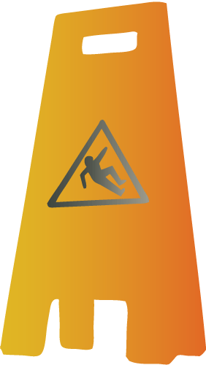****

**Disinfect tub and shower**

**Check and refill dispensers / disinfect dispensers**

**Make bed**

**IMPORTANT! Disinfect ALL high touch areas with BLUE microfiber cloth – Bed rails, controls, tray table, call box, TV remote, telephone, bedside table handle, chair(s), room sink, room light switch, room inner door knob. Clean dresser and night stand.**

**Disinfect sink, sink fixtures and mirror**

**IMPORTANT! Disinfect ALL high touch areas with GREEN microfiber cloth – bathroom inner door knob/plate, bathroom light switch, sink, hand rails by toilet, toilet flush handle, toilet seat, toilet bed pan cleaner.**

**Spot clean and vacuum carpet**

# Damp mop floor. Mop from the farthest corner to the door. Mop bathroom floor last working towards the door.

**Dust using dusting cloth / extension duster / work high to low**